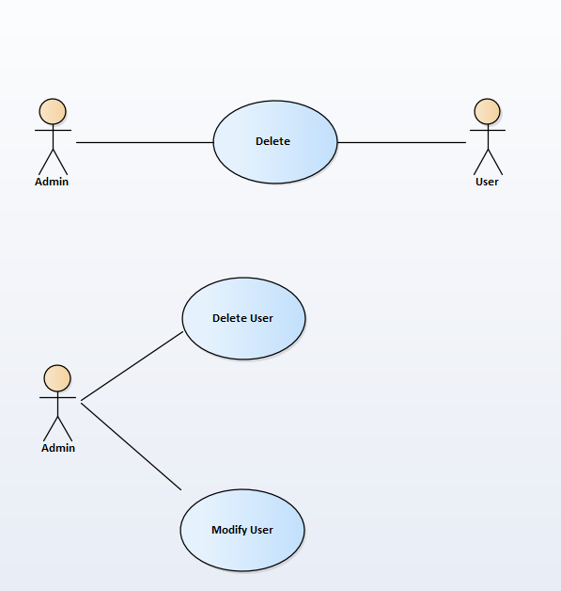

|  |  |
| --- | --- |
| Delete Users | |
| Actors | Admin, User |
| Description | An Admin send the username to the user record system with the command that delete this user in database |
| Data | Username,Password |
| Stimulus | Interface that including username and delete button |
| Response | Message that: Delete successful or Not |
| Comments | Admin must have permission to delete user. Some system, they also keep the record but set a flag to show that this user is deleted |